Chapter 12, Solution 69.

For load 1,
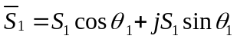
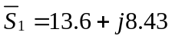 kVA
For load 2,
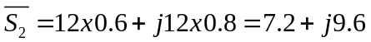 kVA
For load 3,
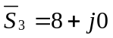 kVA

Therefore,
S = S₁ + S₂ + S₃ = [28.8+j18.03] kVA

Although we can solve this using a delta load, it will be easier to assume our load is wye connected. We also need the wye voltages and will assume that the phase angle on V_{an} = 208/1.73205 = 120.089 is –30 degrees.

Since S = 3VI* or I* = S/(3V) = (33,978∠32.048°)/[3(120.089)∠–30°] = 94.31∠62.05° A.

I_{a} = 94.31∠–62.05° A, I_{b} = 94.31∠177.95° A, I_{c} = 94.31∠57.95° A

I = 138.46 – j86.68 = 163.35∠-32˚ A.

